Lab#13 Create a HTML form that accept the student data like enrollment number, name, email id, password, confirm password, phone number, address, gender, choices of branch and perform client-side validation using JavaScript.

TAGS USED | DESCRIPTION
<!DOCTYPE html> | Declares the document as an HTML5 document.
<html> | Root element of the HTML document.
<head> | Contains metadata and information about the HTML document.
<meta> | Defines metadata such as character encoding and viewport settings.
<title> | Specifies the title shown in the browser tab.
<body> | Contains all visible content of the webpage.
<h1> | Defines the main heading of the registration form.
<form> | Creates a form to collect student details.
<input type="text"> | Accepts enrollment number, name, and phone number.
<input type="email"> | Accepts the student's email address.
<input type="password"> | Accepts password and confirm password securely by hiding characters.
<textarea> | Accepts the student's address in multiple lines.
<input type="radio"> | Allows the student to select gender.
<select> | Creates a dropdown list for selecting a branch.
<option> | Defines an option inside the dropdown list.
<input type="submit"> | Creates a button to submit the registration form.
<br> | Inserts a line break.
<script> | Contains JavaScript code for form validation.
function | Defines the validateMyform() function to validate the form.
document.getElementById() | Retrieves an HTML element using its ID.
document.querySelector() | Selects the checked gender radio button.
if | Checks whether a validation condition is true.
alert() | Displays a message or validation error to the user.
return false | Stops form submission when validation fails.
return true | Allows form submission when all validations pass.
.match() | Checks whether a value matches a specified regular expression.

Final Outcome:

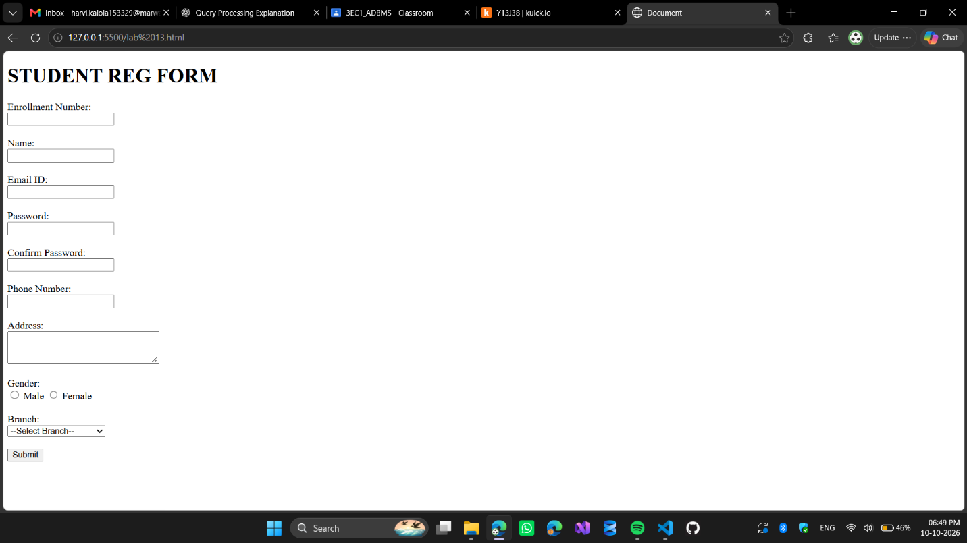

Code Snippet:

<!DOCTYPE html>
<html lang="en">

<head>
<meta charset="UTF-8">
<meta name="viewport" content="width=device-width, initial-scale=1.0">
<title>Document</title>
</head>

<body>

<h1> STUDENT REG FORM</h1>
<form id="studentForm" onsubmit="return validateMyform()">

Enrollment Number: <br>
<input type="text" id="enrollment"><br><br>

Name: <br>
<input type="text" id="name"><br><br>

Email ID: <br>
<input type="email" id="email"><br><br>

Password: <br>
<input type="password" id="password"><br><br>

Confirm Password: <br>
<input type="password" id="confirmPassword"><br><br>

Phone Number: <br>
<input type="text" id="phone"><br><br>

Address: <br>
<textarea id="address" rows="3" cols="30"></textarea><br><br>

Gender: <br>
<input type="radio" name="gender" value="Male"> Male
<input type="radio" name="gender" value="Female"> Female
<br><br>

Branch: <br>
<select id="branch">
<option value="">--Select Branch--</option>
<option value="Computer Engineering">Computer Engineering</option>
<option value="IT Engineering">IT Engineering</option>
<option value="Electronics">Electronics</option>
<option value="Mechanical">Mechanical</option>
<option value="Civil">Civil</option>
</select><br><br>

<input type="submit" value="Submit">
</form>
<script>
function validateMyform() {
let enrollment = document.getElementById("enrollment").value;
let name = document.getElementById("name").value;
let email = document.getElementById("email").value;
let password = document.getElementById("password").value;
let confirmPassword = document.getElementById("confirmPassword").value;
let phone = document.getElementById("phone").value;
let address = document.getElementById("address").value;
let gender = document.querySelector('input[name="gender"]:checked');
let branch = document.getElementById("branch").value;

if (enrollment === "" || name === "" || email === "" || password === "" || confirmPassword === "" || phone === "" || address === "" || !gender || branch === "") {
alert("please fill out all deatils");
return false;
}

if (enrollment === "") {
alert("Please enter enrollment number.");
return false;
}

if (name === "") {
alert("Please enter your name.");
return false;
}
emailpattern = /^[a-z]+\.{1}[a-z]+[0-9]{6}@marwadiuniversity\.ac\.in$/
if (!email.match(emailpattern)) {
alert("Invalid email address");
return false;
}

if (password !== confirmPassword) {
alert("password and confirm password not match");
return false;
}

if (password.length < 6) {
alert("Password must be at least 6 characters long!");
return false;
}

phonepattern = /^[0-9]{10}$/
if (!phone.match(phonepattern)) {
alert("Invalid phone number");
return false;
}
alert("Form Submitted Successfully!");
return true;
}
</script>
</body>

</html>

